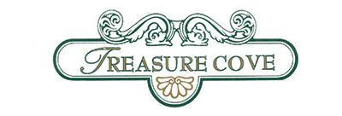

Treasure Cove Homeowners Association
Board 2024-2026 | Position | Committee
Mr. Vaughn Delaney | President | Security
Mr. John Christie | Vice-President. | Maintenance
Ms. Cherise Archer | Treasurer | Finance
Mrs. Robyn Davis | Secretary/Social | Social Events
Board of Directors

